CONNECTED COMMUNITIES | Easy-read information sheet
Please tell us if you need this information in a different language to English,
and we will try to provide it.

Introduction
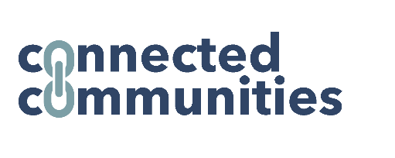 | This document explains what the Connected Communities project is, and how you can take part if you want to.
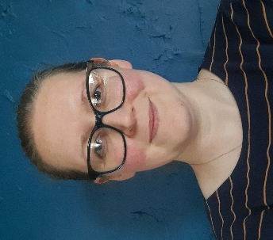 | My name is Jo Weldon
 | I'm a researcher that works at the University of Central Lancashire
 | I’m working on a project for the National Institute for Health and Care Research.
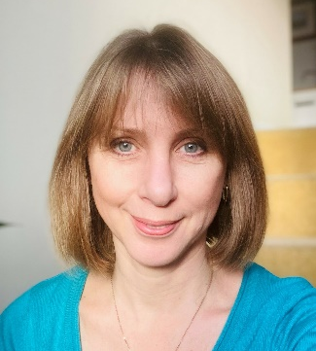 | I'm working with some other researchers who you might meet:  Kathryn Berzins
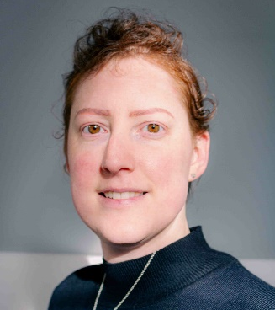 | And Danielle Christian

The project and you
This is a research project about local support services that use people known as signposters.
Signposters link people up with different kinds of help and activities in the community where they live.
We're calling this type of work "person-centred community-based support services".
What happens is
- Someone is (self-)referred to a service.
- A signposter talks with them to find out what help they want or what activities they would like to do.
- Then the signposter helps them to access these things.
We want to find out about the way these services are set up by talking to two groups of people:
- people who use the service to find local support in their community, and
- people who work for the service.
 | We would like to talk to you about what it was like for you to use this kind of support service, and if the COVID-19 pandemic affected your involvement.
 | One of our researchers will talk to you for up to an hour about what you think works well, and not so well about the way the support service you have used is run.
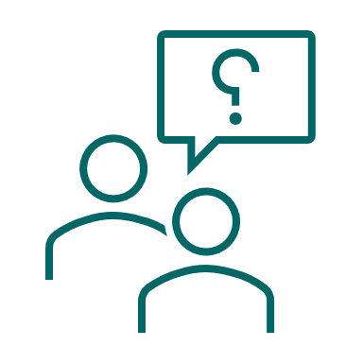 | Also, we will briefly ask about information you received to help you decide whether to take part in this discussion.
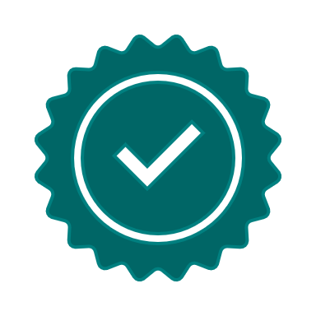 | At the end of the project, we'll produce advice about how these services work best.  This will help other people set up similar services in other places.

What will happen?
We can talk to you about the service whenever it is convenient for you.
The researcher will offer you a choice of dates and times.
You can also choose where the discussion takes place.
We could talk over the phone,
or through a video-conferencing weblink
(this will be through Microsoft Teams – and you won’t need to install any new software),
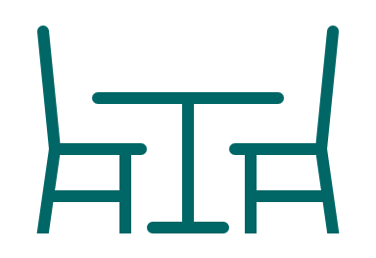 | or if you would like to speak face-to-face, we can meet you in a private space at your local Social Prescribing service.
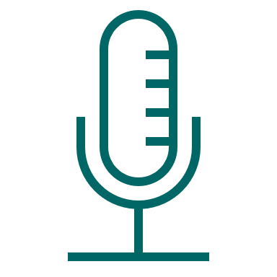 | We will record your agreement to take part (known as 'consent') before we interview you.  To do this you will be read some statements aloud, and we'll ask you to answer yes or no to each of them.  This can be done on a written document too, where you would write your initials instead of saying ‘yes’.

What’s good about it?
The good things about taking part are:
You'll have a chance to tell us about how you felt about using your local support service, and if the COVID-19 pandemic affected your involvement with that service.
You'll also be able to help us to understand how these services work best.
This information will be used to help other people set up similar services in different communities.
If you are a service user, we will offer you a £25 gift voucher for giving us an hour of your time.
It's your choice whether you accept the gift voucher
- if you already receive any state benefits you might want to check with a benefits advisor that receiving this won't affect your future benefit payments.

What might be bad about it?
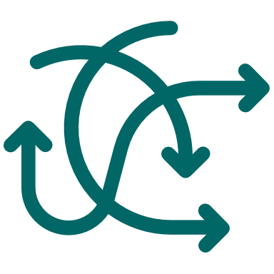 | The bad things about taking part might be:  The discussion will mean speaking for up to an hour with one of our research team.  Some questions might be difficult to answer, but we can help you by asking questions in different ways.
It's OK if there are any questions that you don't want to answer, or if you want to tell us to stop the discussion.
You don't have to give a reason for not answering or stopping.
If you choose to speak to us face-to-face, we will arrange to meet you in an airy space to reduce the risk of COVID-19.
We will also encourage using a mask (face covering) and social distancing.

Do I have to take part?
You can say no if you don't want to talk to us.
It won't affect how you're treated – now, or in the future.
It's also OK to change your mind - for example, you might say ‘yes’ to a discussion with us, but decide later that you don't want to do it.

What happens to what I tell you?
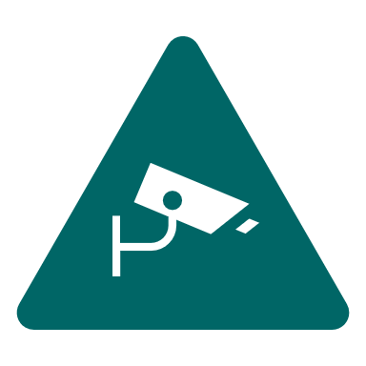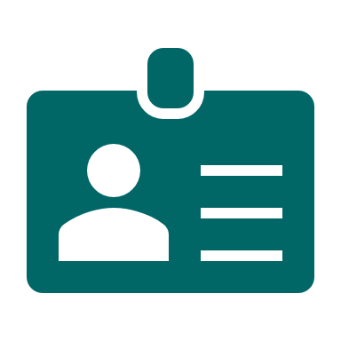 | In this research study we will use information from you.  We will only use information that we need for the research study. You won't need to share any personal information with us when we talk.
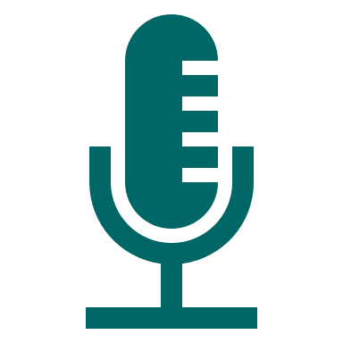 | We will record the discussion.  This helps us to make sure we don't miss any of the important things you tell us.
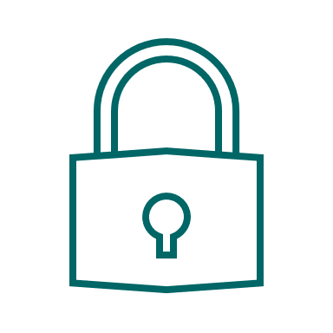 | We will let very few people know your name or contact details, and only if they really need it for this study.  Everyone involved in this study will keep your data safe and secure. Also we will follow all privacy rules.
We might need to tell someone if you share information with us which gives the impression that you or other people could be in some kind of danger.
If this happens, we will try to talk to you about this before telling anyone else.
No one outside the research team will hear your recording. After we've written down what you told us, we will destroy the recording.
We remove your name from the recording and make sure no-one can tell who you are from the reports we write.
These written records of discussions are called transcripts, and you can ask for a copy of your transcript if you want it.
 | At the end of the study, we will save some of the information in case we need to check it.
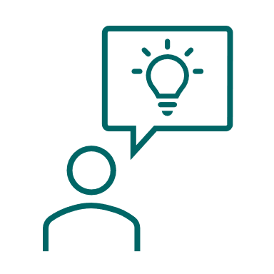 | The information we collect from talking to people will be used to write a report, a guide to help other services, shared at conferences and on a website.  You can ask to receive a copy of the project results when they are finished.
 | You can find out more about how your data is used at https://www.hra.nhs.uk/information-about-patients/

Want to take part in our research?
It's your choice to decide if you want to take part.
You can take some time to think about this or speak to other people about it to help you decide.
If you have any questions about the research you can also talk about it with us before making your decision.
To do this you can email me, at jcweldon@uclan.ac.uk or call my phone number: 01772 89 49 59
This project has been reviewed and approved by an independent Research Ethics Committee (IRAS ID: 314796).
The project is funded by the National Institute of Health and Care Research (NIHR) Applied Research Collaboration National Priorities Programme for Adult Social Care and Social Work award (project ID: ARC271).

