ARC NWC Public Adviser Buddy Scheme

Handbook for public adviser

Our vision:
To improve health equity and applied health research through the voice of the population

ARC NWC Public Adviser Buddy Scheme

ARC NWC public involvement

We are committed to involving members of the public in everything we do, from research projects (coproduction from ideas stage through to sharing research findings and implementing change) to leading our research themes (each theme has two public advisers co leading with our academic leads) and governing our organisations communication and management.
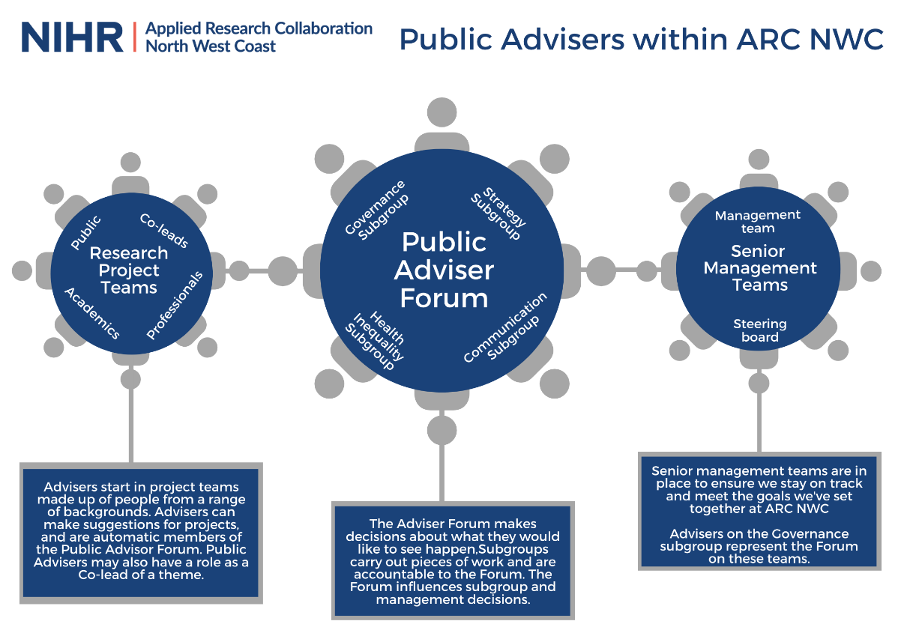

Who are ARC NWC Public Advisers?

A range of people from all parts of the Northwest with wide experience, skills and knowledge. They are very diverse group (ages, ethnicities, backgrounds, postcodes etc), working together as a Team to coproduce research alongside academics and practitioners/clinicians from member organisations.

To get involved public advisers don’t need any specific background or education or previous knowledge or experience. All people’s stories and life experience are important and valued. Public advisers just need an interest in health research, some time to spare and a willingness to share their thoughts and ideas with us.

Our team of public advisers at ARC NWC is continues expending and we welcome new advisers all the time. To ensure that our public adviser that join our team are supported, we the Public, Patient Involvement and Engagement (PPIE) team offer flexibility in methods for getting involved and offer a peer support ARC NWC public adviser buddy scheme.

What is ARC NWC public adviser buddy scheme?

This peer support scheme is to support and encourage new public advisers (PA/s) to confidently get embedded within the ARC NWC and maximise their involvement at all levels through the support of other public advisers (buddy).

What is a Buddy?

A buddy is an ARC NWC experienced public adviser who partners with a new PA during his/her first two months of them joining the ARC NWC. While primarily responsible for offering advice and guidance regarding the day-to-day aspects of being a public adviser and being involved, the buddy may also offer encouragement and knowledge resources, as they help introduce the new PA to the ARC NWC structure. Such as ARC NWC different Themes, Public adviser forum, Health Inequalities Assessment Tool (HIAT) / Health Equity Mainstreaming HEM, ARCFest and etc.

For the buddy; Key characteristics of a buddy include:
- Communicator: A buddy should encourage open communication. The buddy should provide relevant information to the new PA and encourage a process of continued, self-directed learning.
- Motivated: The buddy should have a positive outlook on his/her involvement and use that perspective to help build self-confidence in the new public adviser.
- Share experiences: The buddy can help guide the new PA in many situations based on his/her experience and knowledge obtained in their involvement in the ARC NWC as public advisers.

Why have a buddy?

The purpose of new public advisers being assigned a buddy is to help welcome and support them understanding the ARC NWC to maximise their involvement and contribution. It provides new PAs with a reliable, motivated, single point-of-contact for their basic questions regarding their involvement experience at ACR NWC.

Other advantages of having a buddy include:
- Enable new PA become knowledgeable about ARC NWC practices and organizational culture in a shorter period
- Enable new PA become aware of the different acronyms often used within ARC NWC and research, such as CRN, RDS, CVS, HIAT, etc.
- Ensure that routine queries regarding basic operational issues are dealt with expeditiously
- Reduce the initial confusion and uncertainty faced by all new PAs
- Maximize contribution and involvement across ARC NWC
- Increase the new PA’s self-confidence allowing him/her to focus on adding value to the ARC NWC through their valuable experiences.
- Enable new PA become knowledgeable about different opportunities they can be involved in outside of the ARC NWC and across different ARCs.

Matching Buddy and new PAs

Buddy
All experienced public advisers at the ARC NWC will be asked to express their interest in being a buddy. The ARC NWC PPIE team have details of all public advisers including their background and involvement/contribution within the ARC NWC, which will be used for the purposes of matching a new PAs to potential buddy. The buddies also provide a short personal statement about their motivations for becoming a buddy, and what they might be able to offer to potential new PAs.

New PAs
New public advisers will be contacted by the PPIE team, they will be asked about what they hope to get out of the scheme and any particular characteristics they would value in a buddy, e.g. having experience in area of research interest. Based on this information, the PPIE team will suggest a matching buddy. The PPIE team will then organise a meeting to link both public advisers and support them in initiating further communication.

The new PA will be free to accept the suggestion, or to reject it if they feel the suggested buddy is not suitable for some reason. If the new PA would like a different buddy, the PPIE team will do their best to provide a more suitable match.

If the new PA is happy with a suggested buddy, it is their responsibility of the new PA to keep communication with the buddy via email or other means of communication that they both agree on. It is expected that the buddy to respond promptly.

Buddy Responsibilities:

- Contact and meet with the new PA when they first join the ARC NWC
- Establish a rapport with the new PA
- If possible have a non-formal meeting with the new PA at least once (face to face or remotely)
- Help socialise the new PA to ARC NWC norms and culture
- Answer general/routine questions
- Make introductions
- Ensure an open communication between the new PA and the buddy, respecting confidentiality
- Follow up with the new PA when needed
- Provide continued support beyond the 2-month expiration of the formal relationship if such support is needed and welcomed by the new PA.

Tips for Buddies:
- Don’t worry about being perceived as the expert. Focus your attention on the new PA
- Be patient: It takes time to develop a relationship. Don’t try to cover everything right away
- Be positive: New PAs will grow into their roles if given proper reinforcement
- Don’t try to force a relationship
- Try to identify the new PA’s personality and communication style and adapt accordingly
- Don’t be judgmental, simply offer feedback
- Maintain a good attitude

Monitoring and evaluation

The ARC NWC buddy scheme is new. As such, we need to make sure it is working, for both buddy and new PA. Following the end of a buddy relationship, both buddy and new PA will be asked to provide feedback on how the scheme has worked for them. Copies of feedback forms for buddy and new PA are in Appendix 1 and 2.

What to do if there is a problem

We hope that the majority of buddy relationships will run smoothly. However, if there is a problem, either with the day-to-day running of the Scheme or with the buddy relationship itself, please contact the PPIE team in the first instance.

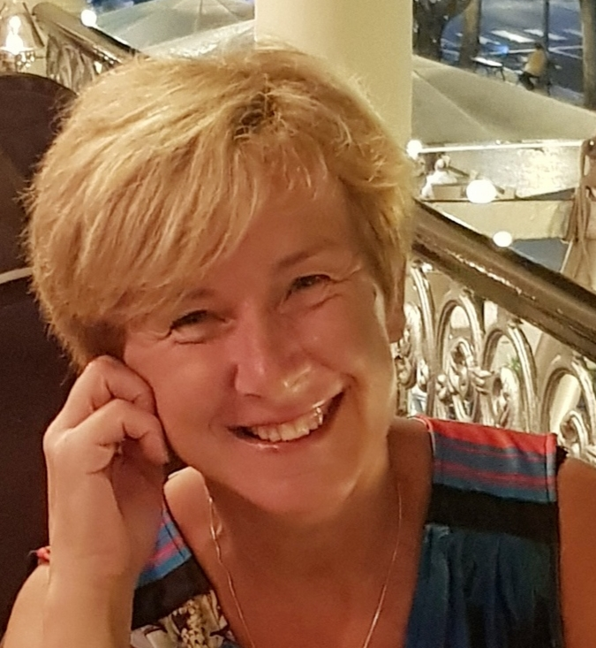
Mrs Ruth Ball
Administrator for Public Advisers
Email: Ruth.Ball@liverpool.ac.uk

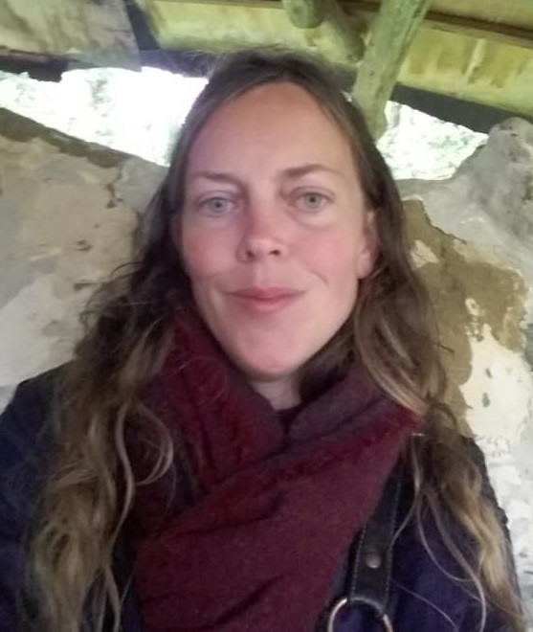

Ms Selina Wallis
Public Involvement manager
Email: selinaw@liverpool.ac.uk

Dr Shaima Hassan
Public involvement research lead
Email: S.M.Hassan@liverpool.ac.uk

Appendix 1

Public Adviser Buddying Evaluation Form – New PA

We would like to evaluate your experience of the buddying process, to assist in the development of future programmes and coaching interventions. All responses will be treated in strictest confidence

Your name: ____________________________________

Question | Response
Has having a buddy after you joined ARC NWC met your expectations so far?
It may be helpful to write your expectations going into the sessions followed by a short summary detailing how each of them have been met (or otherwise).
How many times have you met with your buddy so far? Is this sufficient?
What type of support have you received? Zoom calls, face to face meetings, links to guidance, debriefing, prep before research meetings etc
What kind of topics have you covered?
What has worked well? Can you give examples
What could have worked better? Can you give examples
In your opinion, is your buddy a good ‘match’ for you?
How long do you think the ‘buddying’ should go on for? A set time or as and when you both feel necessary?
Are there any concerns or issues that you would like the PPIE team to support or address to make the experience better?
Do you have any recommendations to improve the ARC NWC PA buddy scheme?
Did you feel that there were enough resources to support the sessions, were you happy with the matching process etc.?
Do you have any further comments?

Appendix 2

Public Adviser Buddying Evaluation Form – Buddy

We would like to evaluate your experience of the buddying process, to assist in the development of future programmes and coaching interventions. All responses will be treated in strictest confidence

Your name: ____________________________________

Question | Response
What was your expectation of you becoming an ARC NWC buddy? And how did providing buddy sessions/meeting/support for new PA meet your expectations?
It may be helpful to write your expectations going into the sessions followed by a short summary detailing how each of them were met (or otherwise).
What worked well?
Give examples of some of the things/approaches you included as a mentor.
What could have worked better?
Give examples of something that didn’t work and you may have changed the approach for it to work better.
How many times have you meet with your New PA? Was this sufficient?
What type of support have you given? Zoom calls, face to face meetings, links to guidance, debriefing, prep before research meetings etc
In your opinion, was your new PA a good ‘match’ for you in your capacity as buddy?
How long do you think the ‘buddying’ should go on for? A set time or as and when you both feel necessary?
Are there any issues or concerns you would like the PPIE team to address or work with you on to help you in your role as a buddy?

Do you have any recommendations to improve the ARC NWC PA buddy scheme?
Did you feel that there were enough resources to support the buddying/mentoring, were you happy with the ‘matching process’, etc.?
Do you have any further comments?

