ARC NWC

PUBLIC ADVISER

WELCOME PACK

Contents

Who, What and Why? 3
What is ARC NWC? 3
What is Public Engagement? 3
Why do Public Engagement? 4
Who is a Public Adviser? 4
Payments 6
Meetings and Activities 7
Training 8
Public Adviser Feedback and Complaints Procedure 9
Further Information and Help 111
Privacy Policy/Statement 12

Who, what and why?

What is ARC NWC?
ARC NWC Applied Research Collaboration.
ARC NWC brings universities, local authorities, NHS organisations and members of the public (Public Advisers) together to work on reducing health inequalities in the following ways:
- Encouraging, supporting and developing health and social care research that is based around local needs.
- Using the partnership to make changes based on research findings more quickly.
- Engaging with and involving public advisers in all activities throughout the research process to ensure that the proposed research relates to their experiences.
You can find out more about ARC NWC by visiting our website:

https://arc-nwc.nihr.ac.uk/get-involved/

What is Public Involvement?
Public Involvement is an umbrella term used in ARC NWC for the many different ways we work with members of the public. This table explains the different ways that research organisations might involve the public:
Participation | Involvement | Engagement
Public take part in a research study, for example:  - Public are recruited to a clinical trial or a research study. | Public are actively involved in research projects and research organisations, for example:  - Public are members of a project advisory or steering group.  - Public are involved in identifying research priorities. | Information and knowledge about research is provided and communicated to the public, for example:  - Public science festivals with debates and presentations on research.  - Raising awareness of research through media, such as television and newspapers.

Public Adviser participation is a key part of ARC NWC research. We use the term ‘Public Involvement’ to refer to involvement and engagement. This includes deciding what is the most important research to do as well as designing and managing our activities, producing the work itself and sharing what we have learnt with others. Engagement includes publicising our work and recruiting the public as participants in ARC NWC research and projects.

Why do Public Involvement?
Whatever the activity, especially research or developing capacity to do research, it is essential to work with service-users’ first-hand experience.
When research could impact on the way something is delivered (for example a policy or health service), it is vital that people who could be affected have a chance to influence the research.
When research is carried out with or by the public, it makes the research more relevant and useful to the people who can benefit from and it will have more impact.
It is the right thing to do - so all of the research that ARC NWC carries out has our ‘public advisers’ at the heart of it.
Working with the public improves the transparency of the research process and accountability. That is why public advisers are involved at every level of the collaboration.

Who is a Public Adviser?
A Public Adviser is a member of the public who is involved in any ARC NWC activity. All ARC NWC Public Advisers are eligible and invited to attend the Public Advisers Forum.
The chart on the following page shows that public advisers are involved in activities throughout all of ARC NWC.

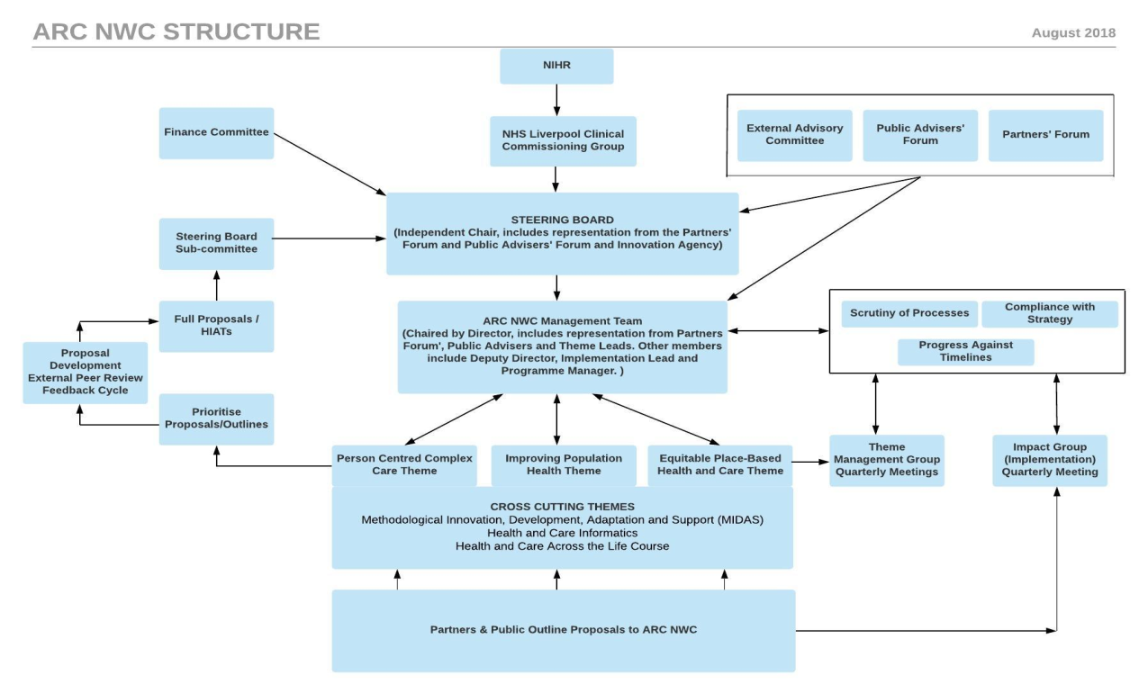

Public Advisers are embedded through the structure of ARC NWC, with representatives on the steering board, management committee, ARC sub-groups and on the research and cross-cutting themes committees.

We have a Public Involvement Manager (Selina Wallis), a four-day a week administration post (Mrs Ruth Ball) and a Public and Community Involvement, Engagement and Participation (PCIEP) Strategic Lead (Dr Paula Bryne). You can contact the ARC public involvement team via the email arcnwc@liverpool.ac.uk.

Payments

We value public engagement and it is our policy at ARC NWC that Public Advisers should be reimbursed when they have contributed to our work.

Payment of Expenses
When asked to carry out work with ARC NWC, all reasonable expenses incurred by public advisers will be either paid or reimbursed. (Receipts must be provided.)
We also pay fees for advisers’ time, depending on the duration and activity. (For example, those attending a Public Advisers Forum would receive a fee payment of £25.)
Please read the ARC NWC payment policy for full details about expenses and payments https://arc-nwc.nihr.ac.uk/get-involved

Meetings and activities
You can use this form to record any activities and training you undertake. This is for your own reference. It will help with keeping track of your development and experience as an adviser, as well as being your own financial record. The first line has been filled in as an example.
Date | Meeting / Activity name | Fee | Expenses | Submitted form (date)
21.01.2020 | Public Adviser Forum | £25 | £4.50 | 05.02.2020

Training
Public Advisers do not need any particular skills, training or qualifications. We are interested in your views, opinions and personal experiences about the topics we are working on. These are what qualify you as a Public Adviser and this is all you need to help shape ARC NWC research.
Your personal experience relating to the topic of a project or theme means you can make a valuable contribution to ARC NWC work. There might be activities that require a Public Adviser to have a particular skill or understanding and we will look to provide you with the training or support you need to carry out the activity. It will always be your choice whether or not you become involved.
The Public Involvement team are responsible for training and development in ARC NWC and the public involvement training topics are decided by the Public Advisers Forum. You will receive regular updates about training opportunities available to Public Advisers throughout the year.
If you have any questions or concerns about training please raise them at a Public Adviser Forum or contact Selina Wallis (details at the end of this guide).

Learning about ARC NWC
Through attending meetings and engaging in activities, you will learn more about ARC NWC and its research. We have suggested a few things that will help you become familiar with ARC NWC if you would like to find out more:
- Read the Public Involvement Policy and the Payment Policy https://arc-nwc.nihr.ac.uk/get-involved
- Talk to fellow Public Advisers at the Public Advisers Forum (you will be offered a ‘buddy’ once you have registered as a Public Adviser to make sure you feel welcome and supported)
- Learn about the different Themes in ARC NWC and explore the ARC NWC website https://arc-nwc.nihr.ac.uk/
- Follow ARC NWC on Twitter @arc_nwc

Public Adviser feedback and complaints procedure

Tell us about your experience of working with us:
ARC NWC welcomes feedback, and we want to make sure that Public Advisers are happy in their roles.
If there is a problem:
By following the Code of Conduct, we hope that there will not be any issues or complaints. This procedure explains what to do if you are concerned about someone’s conduct or any other aspect of ARC NWC.

Principles
- We are open to feedback and we are keen to resolve any issues or complaints.
- We will acknowledge receipt of all complaints, and we will try to resolve them within 28 days of receiving them.
- Where possible complaints will be resolved informally with the agreement of all involved.

Informal Resolution
Any complaints or difficulties should be discussed informally before following the formal procedure. If someone is unhappy with the conduct of a Public Adviser or ARC NWC employee they should try to talk to that person to resolve the issue informally.

Formal Procedure
If the issue isn’t resolved informally then Selina Wallis, Manager for Patient/Public/ Community Involvement, should be contacted. The complaint should be put in writing, explaining the issue, why the complaint is being made, and how they think the issue can be resolved.
Within seven working days, Selina will contact all the people involved in the complaint to find out each person’s point of view. Selina might ask for any written documents that would help clarify the situation. Everyone involved has the option to bring support or representation to meetings about the complaint. At this stage, everyone will work together to try to resolve the problem. If the complaint is not resolved or if it is of a very serious issue then it will be discussed with the PCIE&P Academic Lead - Dr Paula Byrne. A decision will then be made as to whether further action is required. The decision will be communicated to everyone involved.

Further information and help

In addition to this pack, you should have a copy of the Public Engagement Policy, and the Payment Policy. Please take the time to read these documents.

Contacts
Manager for Patient/Public/Community Involvement - Selina Wallis
Email: arcnwc@liverpool.ac.uk

Public Involvement Assistant – Ruth Ball
Email: arcnwc@liverpool.ac.uk

PCIE&P (Patient and Community Involvement, Engagement and Participation) Academic Lead - Dr Paula Byrne
Email: arcnwc@liverpool.ac.uk

Postal Address
ARC NWC Public Involvement Team
Block B, Waterhouse Building
University of Liverpool
Liverpool L69 3GL
Telephone : 0151 795 1404

Websites
ARC NWC: https://arc-nwc.nihr.ac.uk/
NIHR: http://www.nihr.ac.uk/
Citizens Advice: https://www.citizensadvice.org.uk/

Partners
You can see the list of ARC NWC partners here: https://arc-nwc.nihr.ac.uk/about/members/

Social Media
Follow ARC NWC on Twitter for regular updates on research and events - https://twitter.com/arc_nwc?lang=en. All tweets are shown on the website.

Privacy Policy/Statement

By registering at the University of Liverpool as an ARC NWC Public Adviser, you understand that the University is collecting, storing, using and disclosing data about you for any purposes connected with your role as an ARC NWC Public Adviser. The ARC NWC administration requirements are shared between three Universities (Lancaster University, University of Central Lancashire and University of Liverpool). We may need to share your details with relevant ARC NWC colleagues at these universities solely for the purposes of ARC NWC related work or operations. When any requests are made such that we have to process data about you, from any of these named organisations, management of your data will be in accordance with data protection legislation and compliant with any data security requirements of the contractual arrangements between the partners.
The General Data Protection Regulation establishes a framework within which information about individuals can be legally collected, stored, used and disclosed
Further details in ARC NWC's Privacy Policy https://arc-nwc.nihr.ac.uk/privacy-policy/
Any queries regarding your data management please email arcnwc@liverpool.ac.uk

