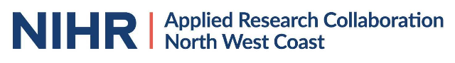
ARC NWC Public Adviser Payment Process
FEE AGREED IN ADVANCE

ADVISOR ATTENDS ACTIVITY

