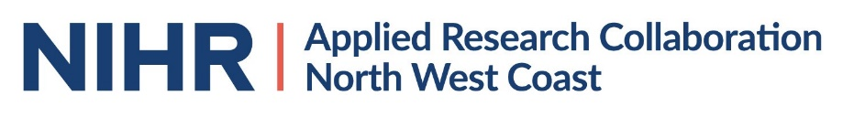

NIHR Applied Research Collaboration NW Coast (ARC NWC)

Data Science Internships application form

Please read the supporting information before completing this form.
Forms to be returned to ARCNWC@uclan.ac.uk by 5pm Monday January 25th 2021.

applicant
Name:
Organisation:
Email: | Telephone:
Position/Role: | Full-time ☐  Part-time ☐  If part time - number of hours worked per week = | Band/Grade:
Please summarise your main responsibilities:

project proposal
Please provide a brief (500 words) description of the project, the support and training required, and any anticipated permissions, approvals and other requirements. Please also describe how the project will involve public advisors and address health inequalities.

Line manager to complete
Please state how you will ensure that the applicant will be supported to complete the internship, including time allocated to attend any relevant training and support.

I am aware that should this application be successful there will be a maximum of £6000 funding available for salary backfill.

I support this internship application.
Name of line manager | Email address | Date
Trust R&D manager (for NHS employees) OR SENIOR MANAGER to complete
Please state how the proposed project aligns with your organisational and ARC priorities.

- I am aware that should this application be successful there will be a maximum of £6000 funding available for salary backfill.

- I support this internship application.
Name of R&D/Senior Manager | Email address | Date
Senior Manager/R&D manager to save as pdf and send a copy of the final form as an email attachment to ARCNWC@uclan.ac.uk

If you have queries regarding the completion of this form, please contact Colette Miller cmiller5@uclan.ac.uk or George Georgiou ggeorgiou4@uclan.ac.uk

